## **Hands-On Activity: Installing and loading tidyverse**

**TOTAL POINTS 1**

1.

Question 1



## Activity overview



In the last activity, you explored the R sandbox and used some R packages such as the tidyverse. In this activity, you’ll explore further with the tidyverse collection of packages and learn about them using the browseVignettes function.

By the end of this activity, you will know how to easily load vignettes. Moving forward, you can use the browseVignettes function to access and review included documentation to better understand each R package you will use.

## Install the tidyverse



If you have not yet installed the tidyverse, open RStudio.

Log in, navigate to the console, type install.packages("tidyverse"), and press Enter (Windows) or Return (Mac).

Then wait as RStudio installs the tidyverse packages (be patient, this can take a little bit). You’ll receive a message that the install is done.

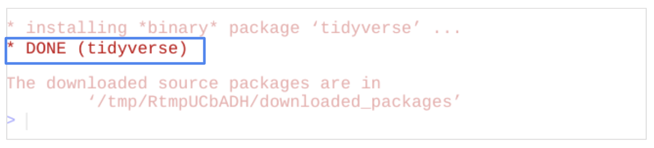

*installing *binary* package 'tidyverse'

*DONE (tidyverse)

The downloaded source packages are in

'/tmp/RtmpUCbADH/downloaded_packages'

>

## Load the tidyverse



Once the tidyverse packages have been installed, load them so that they are available in your current R session. Load the core tidyverse with the library command. The core tidyverse contains the main packages that work together to make your data analysis smooth and efficient.

To load the core tidyverse, type library(tidyverse) and press Enter (Windows) or Return (Mac).

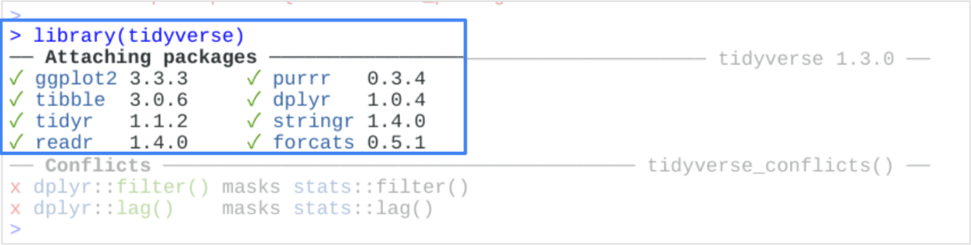

The output in the console indicates that you have loaded the core tidyverse. Each of the core packages has a green check next to it.

The output also lists conflicts. Conflicts report which objects have the same name in two or more places within your session. This usually happens because an object in your workspace or a package you installed is masking a system object of the same name.

Since you most recently loaded the tidyverse packages, they will be the default packages for your current session.

## Read tidyverse vignettes



A vignette is documentation that acts as a guide to an R package. A vignette shares details about the problem that the package is designed to solve and how the included functions can help you solve it. The browseVignettes function allows you to read through vignettes of a loaded package.

To check out vignettes for one specific package, type browseVignettes(“packagename”) and press Enter (Windows) or Return (Mac). Remember that functions are case-sensitive in R, so “Vignettes” must have a capital V.

For example if you execute the browseVignettes() function on ggplot2, browseVignettes(“ggplot2”), you will have the following outcome:

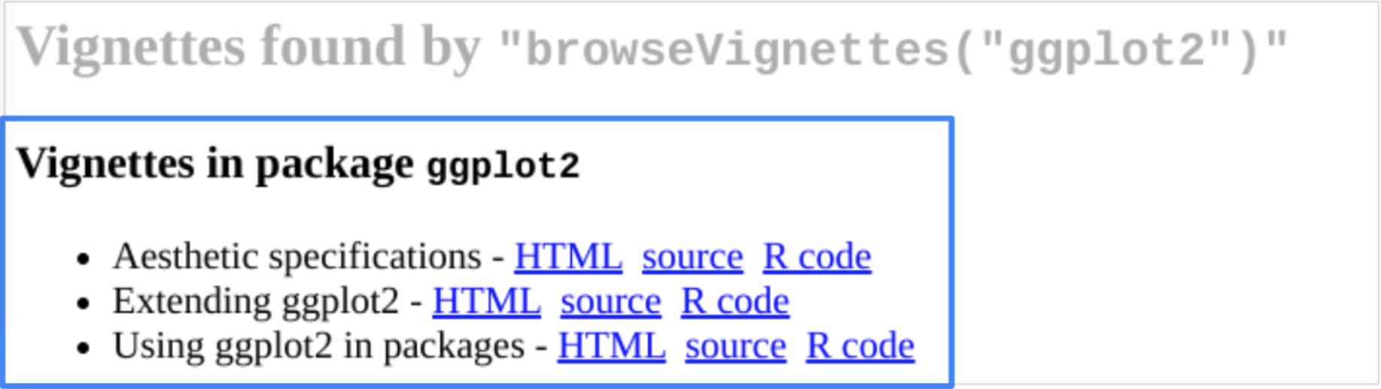

If you are using RStudio Cloud, running this function will open a new browser tab with links to the vignettes.

## Reflection



In this activity, you explored the tidyverse package and learned about vignettes. In the text box below, write 2-3 sentences (40-60 words) in response to each of the following questions:

* How might the tidyverse and its packages help you as you learn how to program in R?
* What impact will the browseVignettes function have on your analysis?

**1 / 1 point**

the package is ready mad code so the code is already developed we just need to know when to use it. It helps us to save a lot of time. browseVignettes is the best tool if we want to know more depth about the package.

**Correct**

Congratulations on completing this hands-on activity! A good response would include how using the tidyverse packages help you read, manipulate, visualize, and do many other important things with data.

Tidyverse was designed to improve the overall workflow for analysts. Since the packages are all integrated with each other, your analysis will be more efficient. You can use the browseVignettes function to find out more about each package and how to use it.